Task 2
Page 1
Created a dashboard for
- Total Revenue Generated
- Total Orders Received
- Total Unique Customers
- Average Order Value

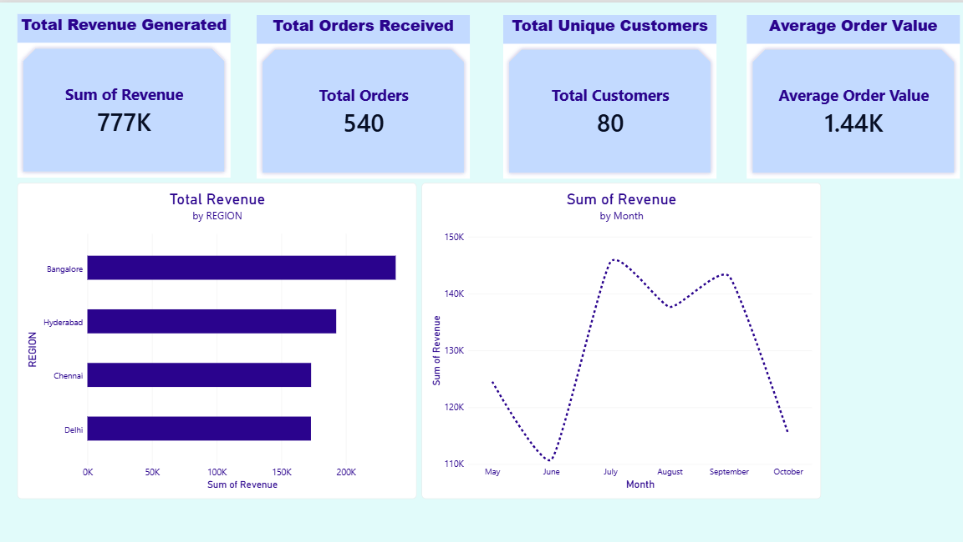

Page 2
Created a dashboard for
- Sum of Revenue per Year using a Line Chart and a Year Slicer in Power BI.
- Sum of Revenue by Category using a Donut Chart

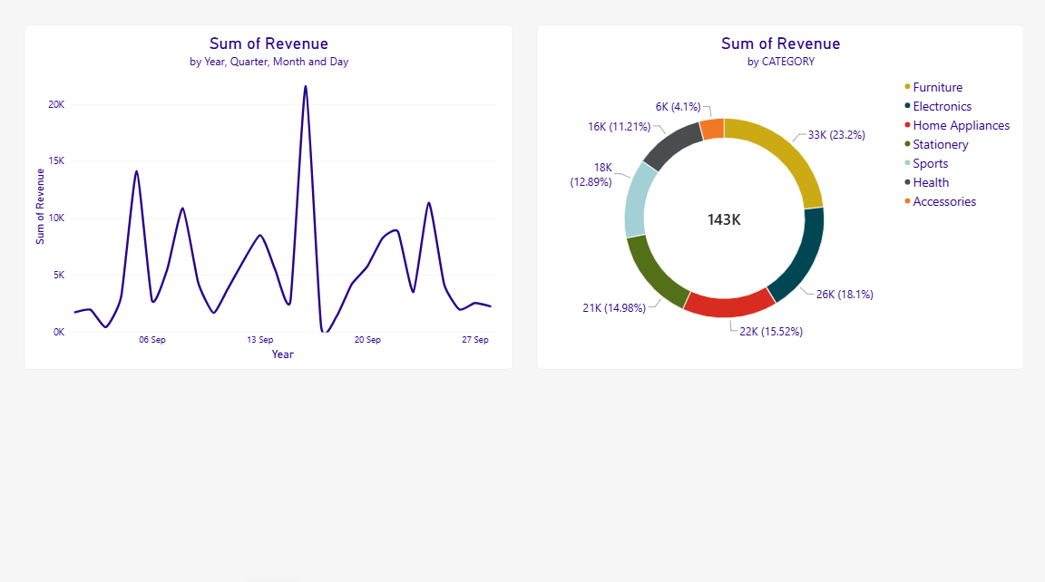

Page 3
Created a dashboard for
- Revenue Performance by Region
- Product Quantity Distribution Across Regions
- Daily Order Trends by Month
- Regional Sales and Quantity Analysis
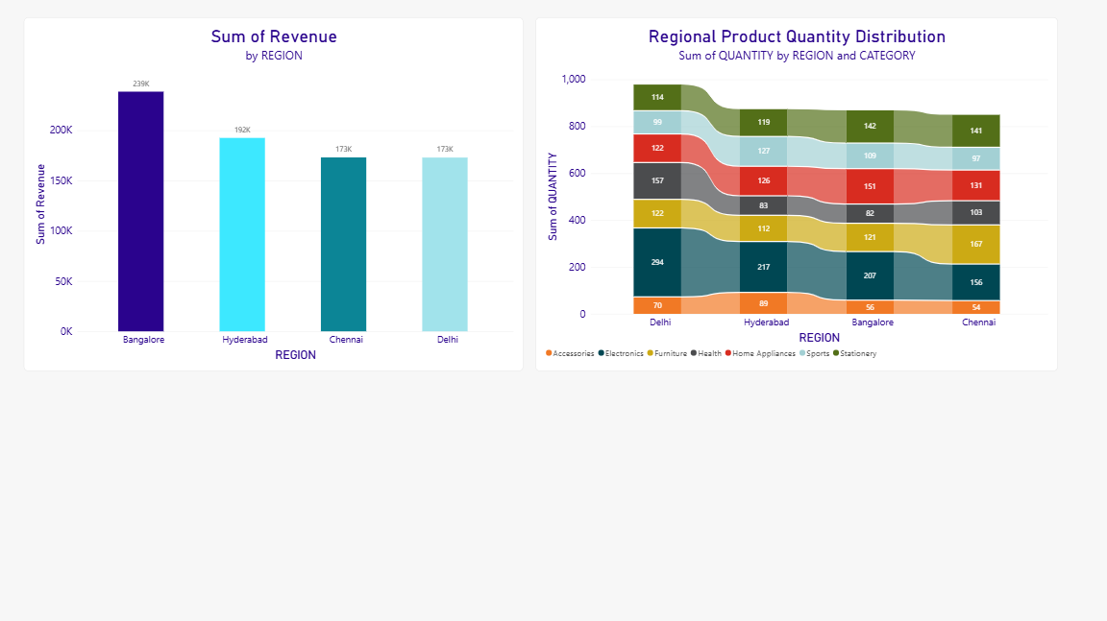

Page 4
Created a dashboard for
1.Analysing Monthly order Volume Trend
2. Sum of Revenue and First Customer
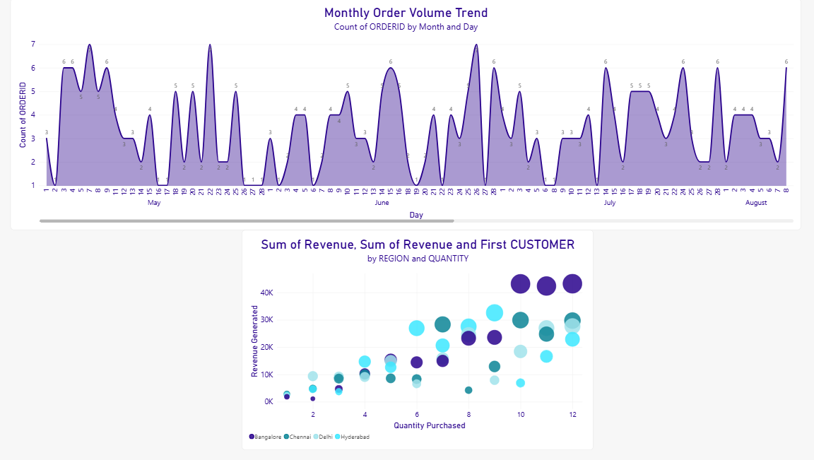

Page 5
Created a dashboard for
- Revenue Contribution by Product and Category


